**Course: Algorithm**  
**Prof. Prem Nair**  
**Student: Binh Van Tran**  
**ID: 986648**  
**Homework: Lab 10**

1. ***Problem 1 – Insertion***
   1. Insert 1

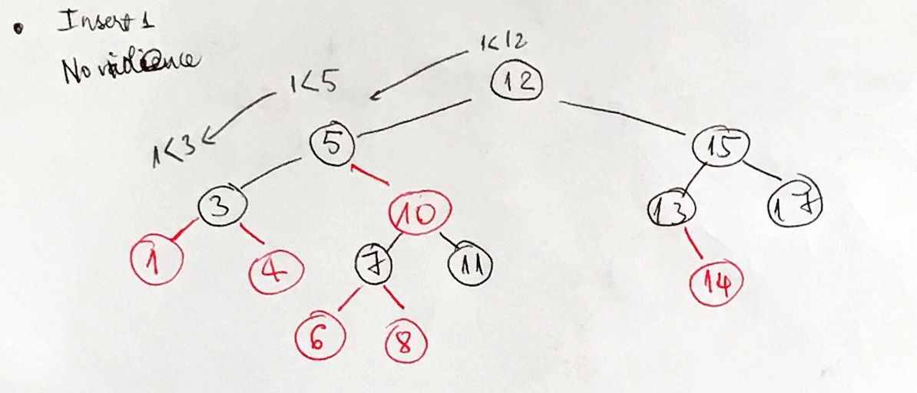

* 1. Insert 13.5

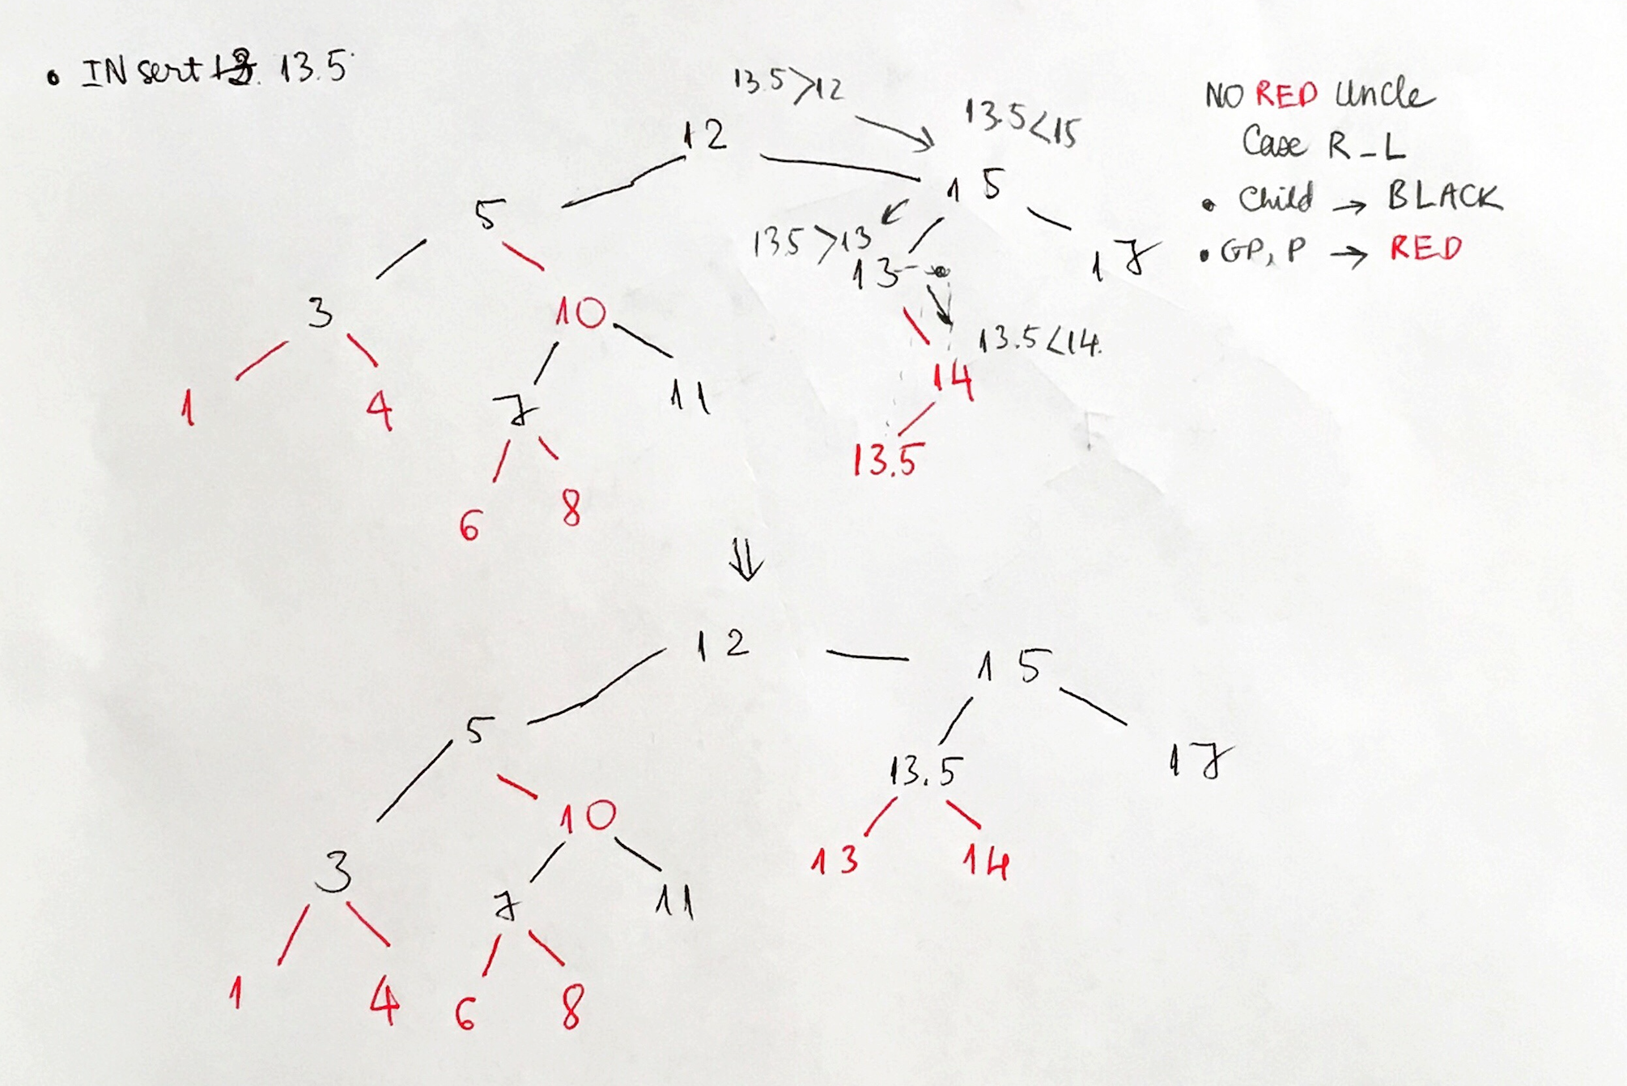

* 1. Insert 14.5

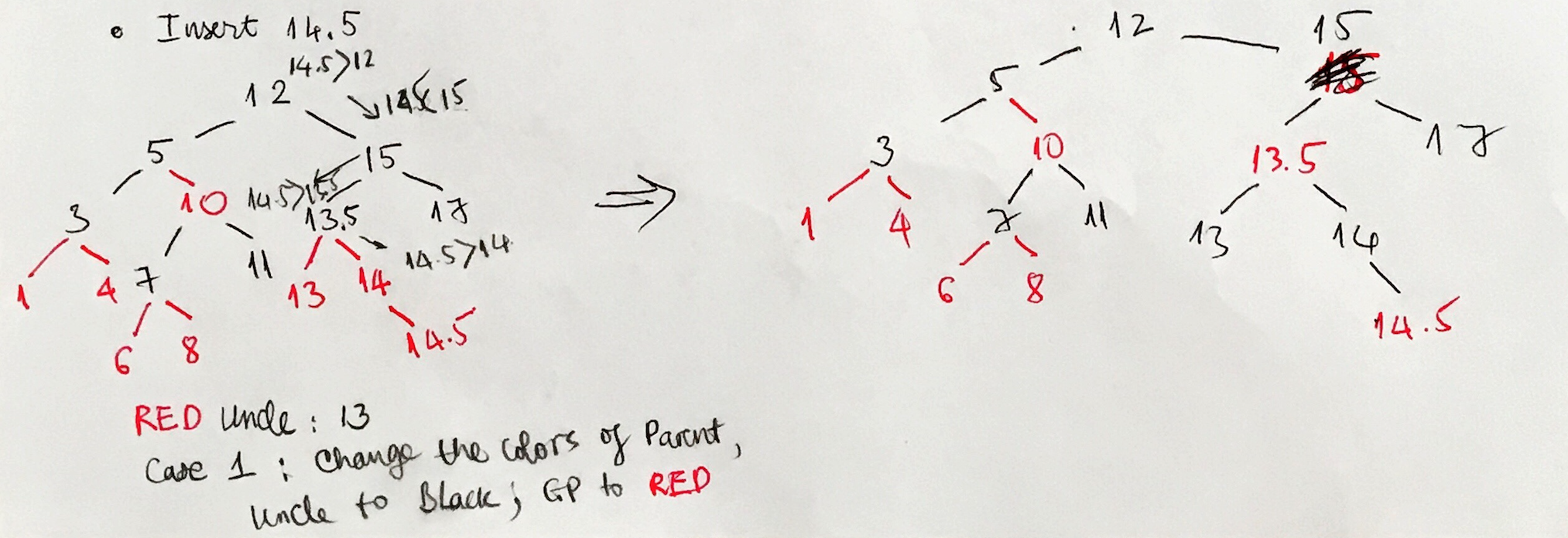

* 1. Insert 9

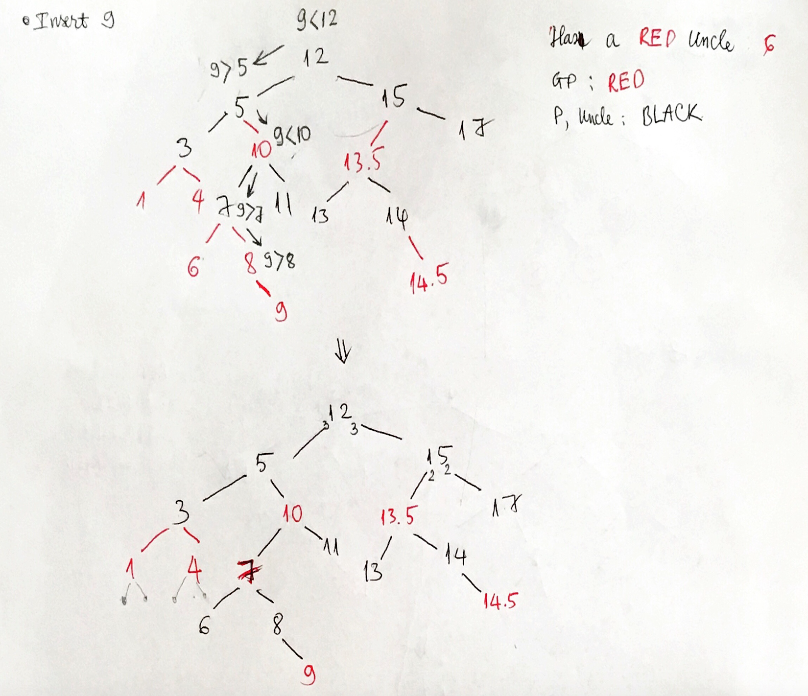

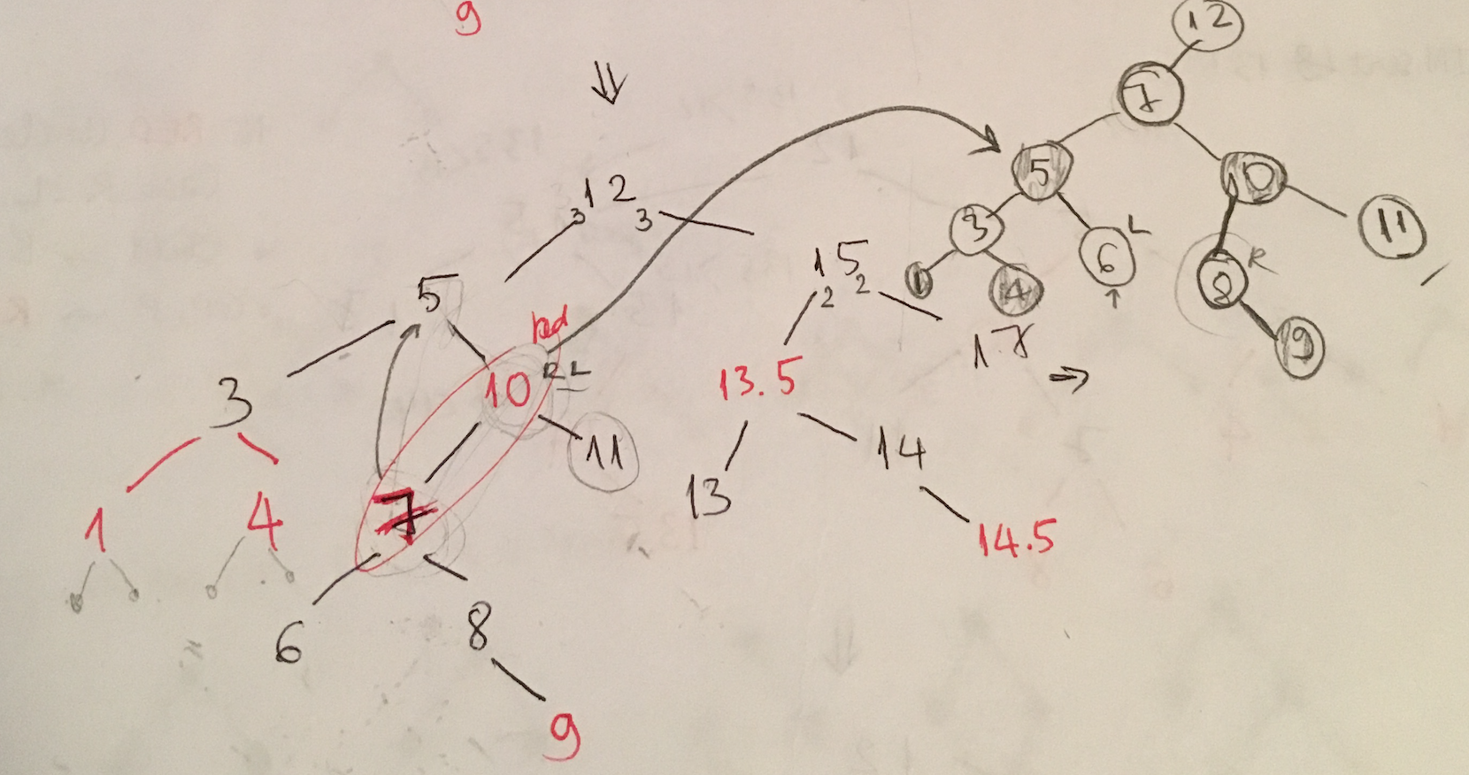

1. ***Problem 2 – Indicate the color and insert new node***
   1. Coloring the tree

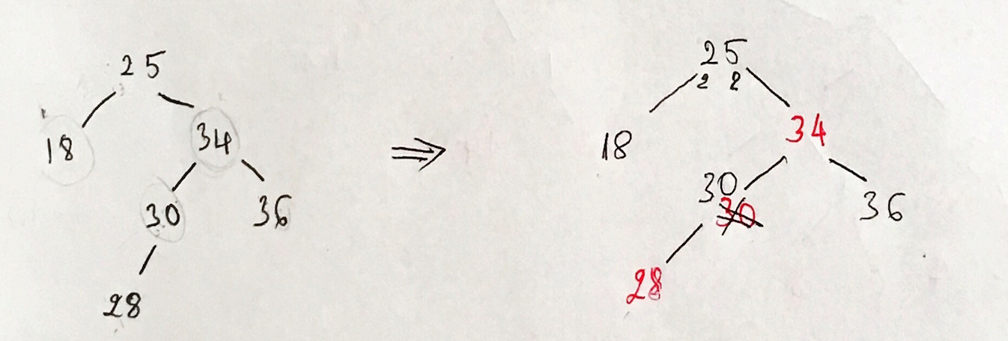

* 1. Insert 29

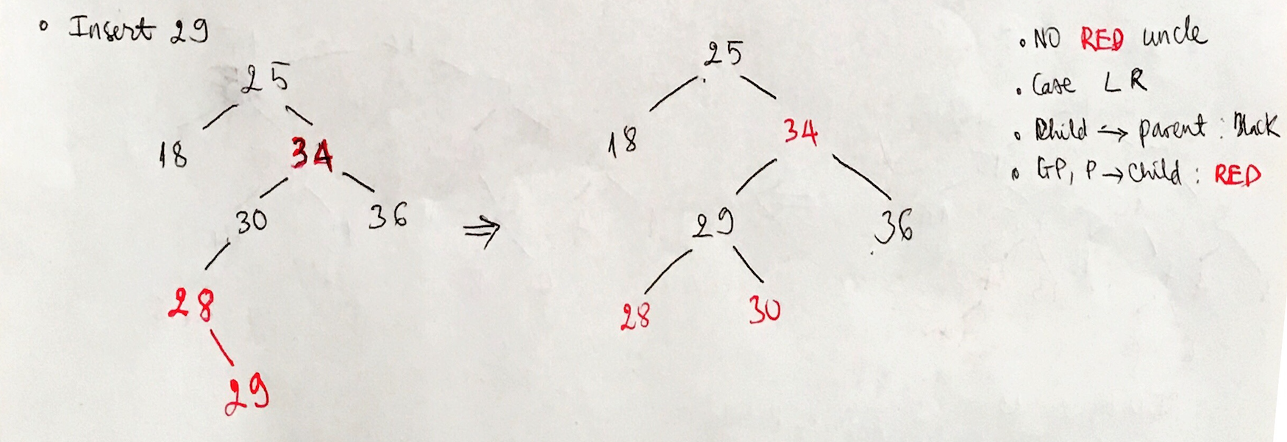

1. ***Problem 3 – Exploration***
   1. How many Red-Black Trees

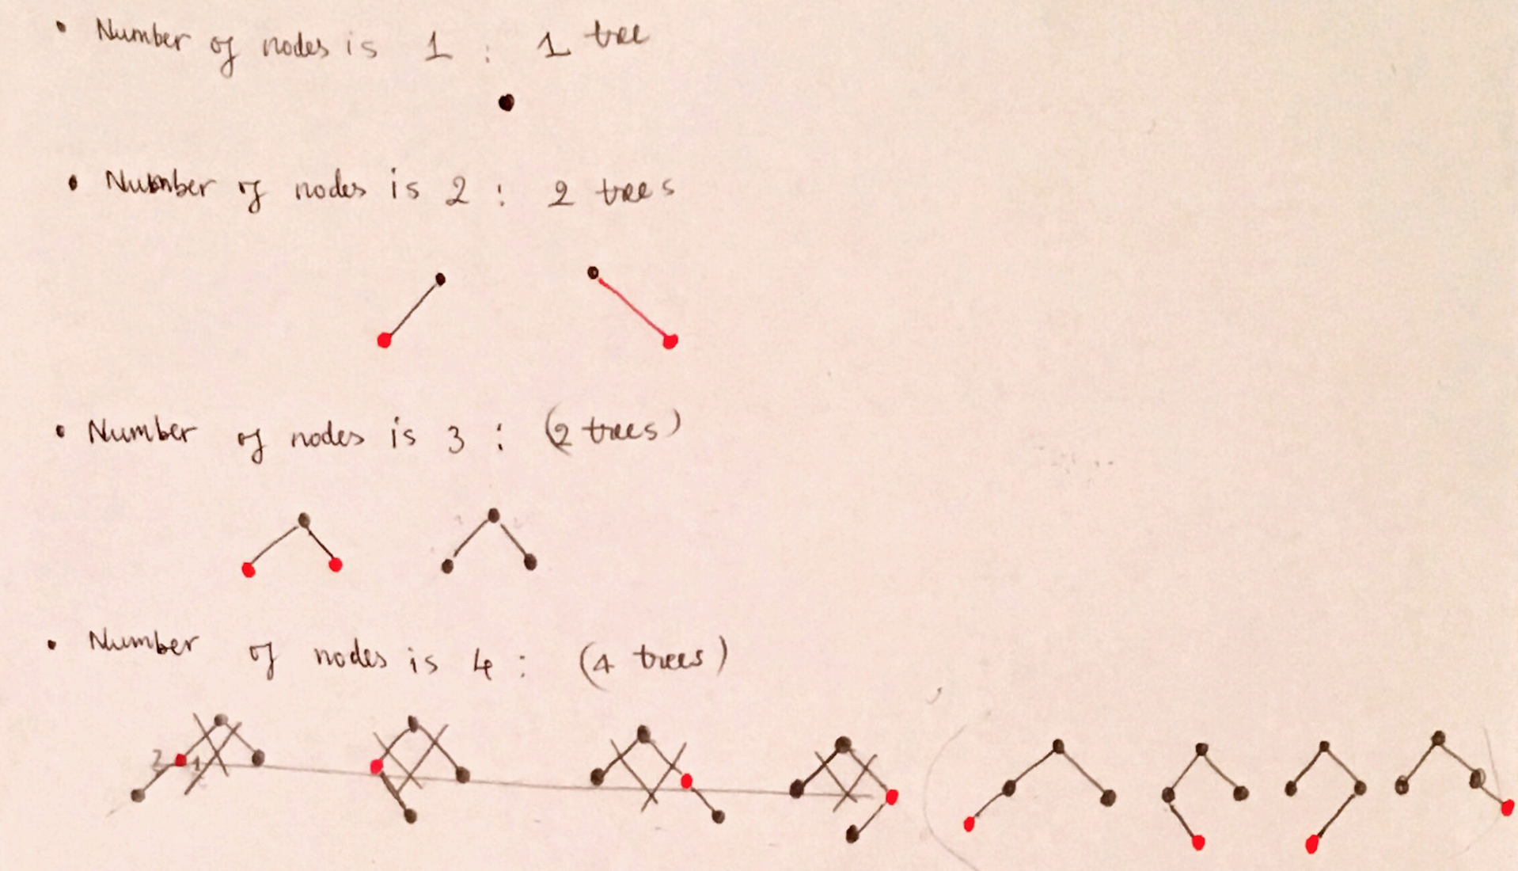

**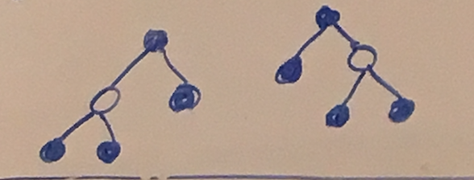***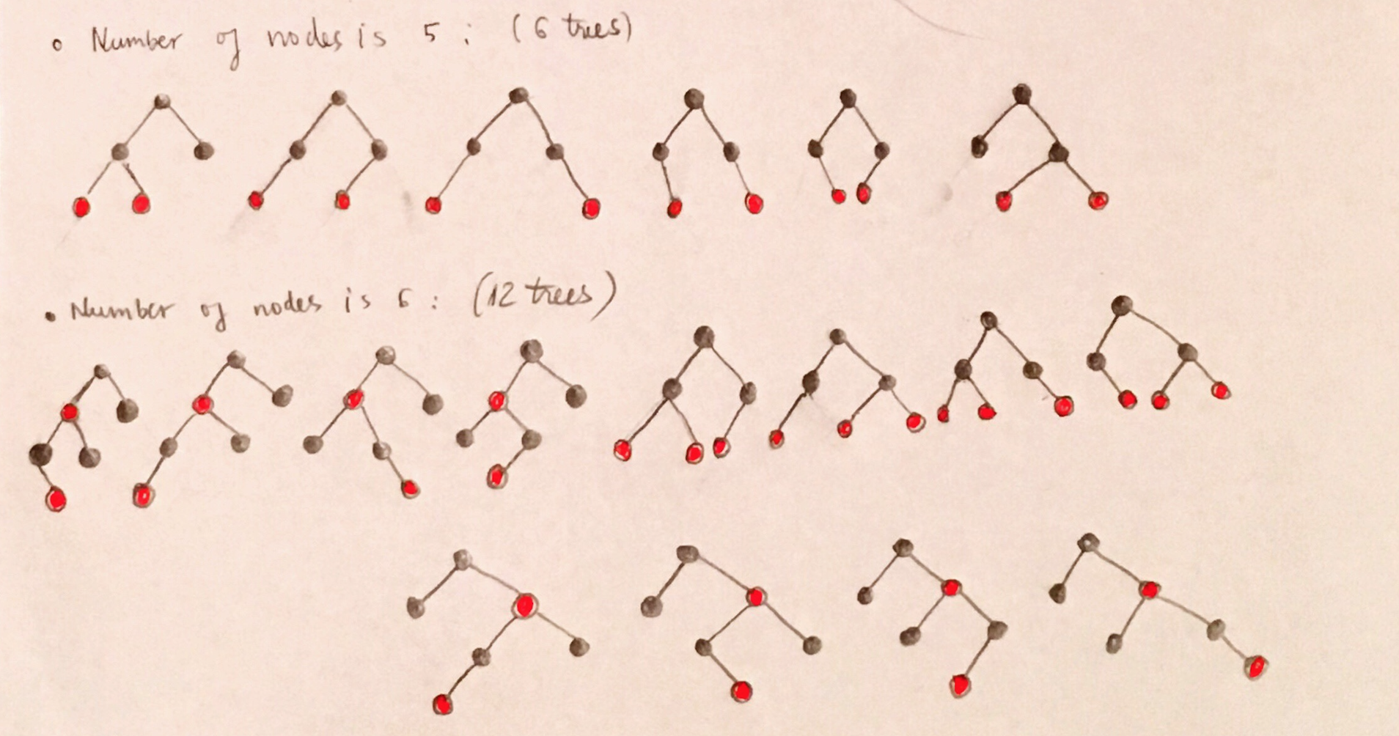*

* 1. Maximum value of the ratio of #Red nodes/#Black nodes: 1:1 (to make sure root is always black and there are no two consecutive red nodes)
  2. Minimum value of the ratio of #Red nodes/#Black nodes: 0 (all are black nodes)